Dispute Redressal Module

Maandhan.in

CSC e-Governance Services India Limited 2019

Contents
What is dispute module? 3
Procedure to resolve dispute cases: 4
Step 1 4
Step 2 4
Step 3 4
Step 4 5
Step 5 6
Step 6 6
Step 7 6
Step 8 6
Step 9 7

What is dispute module?
A dispute function in Maandhan.in portal is to handle & resolve the cases of customers whose mandate forms have been rejected due to invalid bank details and need correction by customers.

Procedure to resolve dispute cases:

Step 1
Open https://maandhan.in.

Step 2
User has options to login Self Enrollment or by CSC VLE.
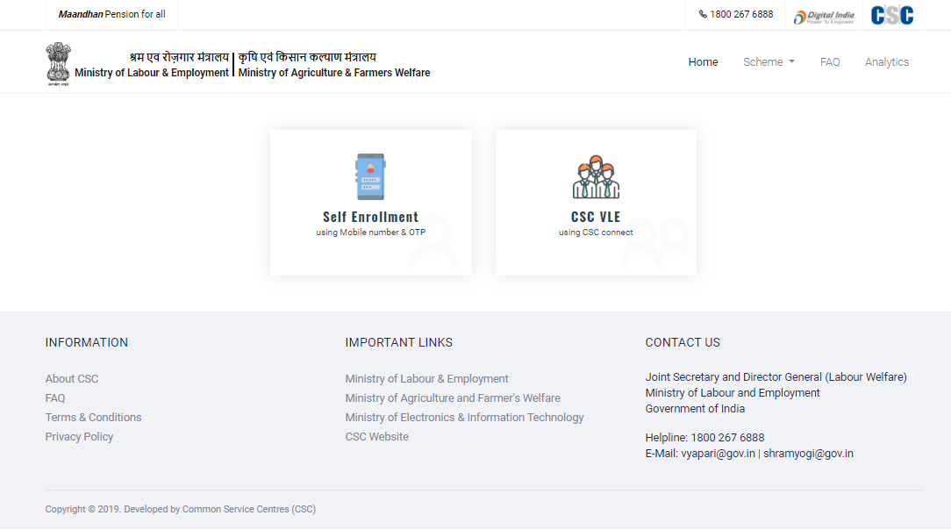

Step 3
For VLE Login users, they have to enter their CSC ID & Password and hit SIGN IN button.
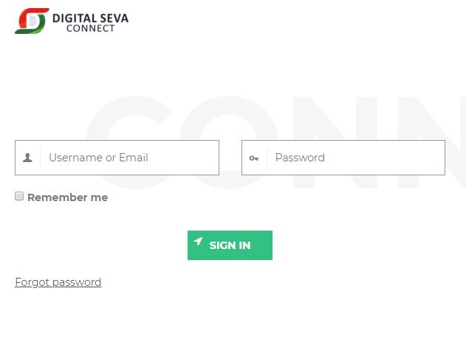

Step 4
For Guest Login users, they have to enter their Mobile Number, Captcha and click on Proceed button.
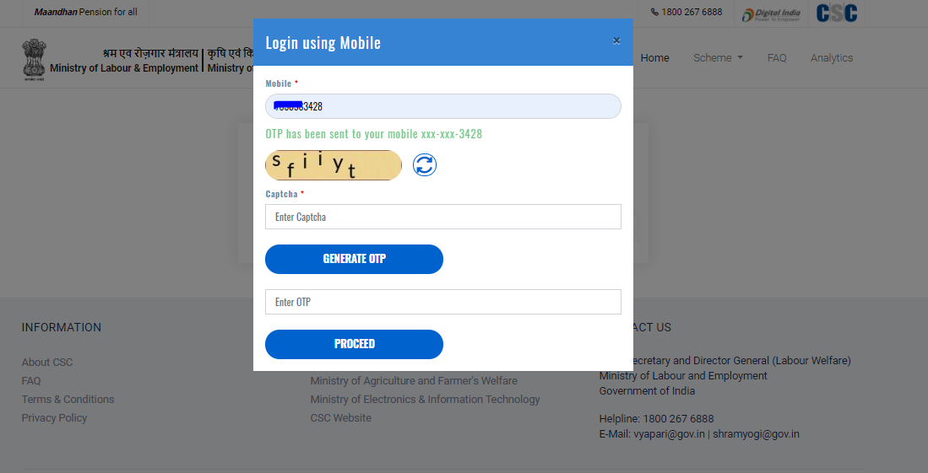

Step 5
Now User/VLE have successfully login to the dashboard. Click on “Dispute” tab.
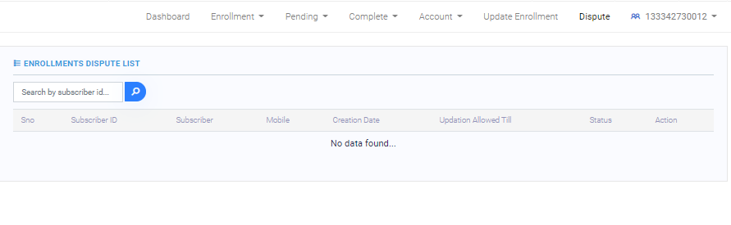

Step 6
In dispute table, VLE can see the number of rejected enrolments out of the total enrolments he/she has done.
Similarly, user can see his/her rejected enrolments details.
Rejected enrolment details available on the portal are following:
- Subscriber ID
- Subscriber Name
- Mobile Number
- Creation Date (Date on which dispute details are available on portal)
- Update allowed till
- Status
- Action

Step 7
Now user/VLE will click on Action required.

Step 8
A form will get open where updation is required and user/VLE can continue to complete the process.
For example:
- If mandate is rejected because of the incorrect bank details then user has to update his/her bank details.
- Next, print the mandate form.
- Sign and upload the mandate form in the panel.

Step 9
Once the details are updated, dispute cases will be resolved.

