Steps for updating FTTH survey and Daily GPON status through an app.
FTTH Survey
For this, please go through the steps given below:

- Download the app by clicking on the link given below
https://www.wifichoupal.in/

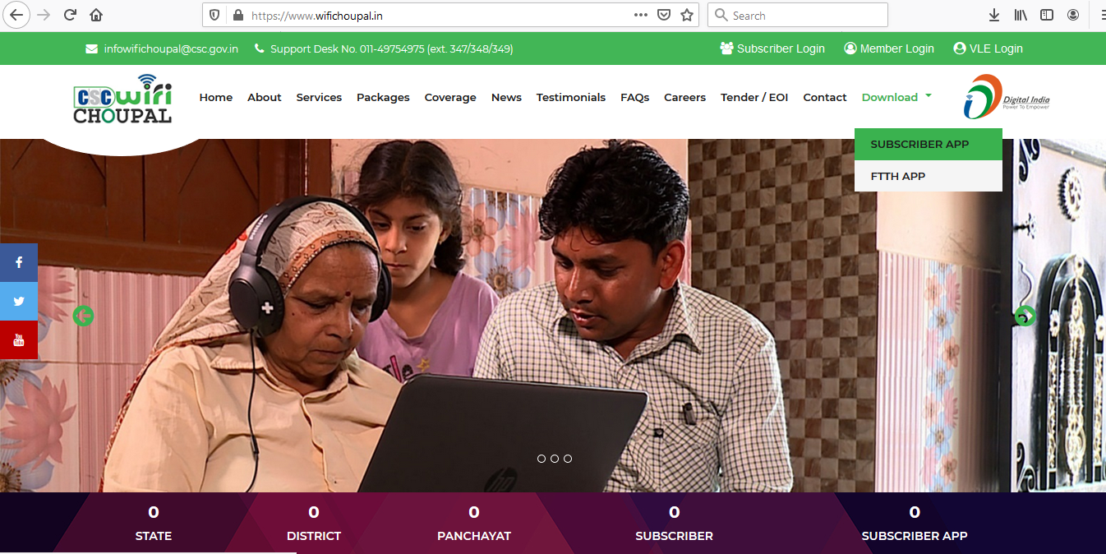

- On downloading the app, welcome screen will appear.
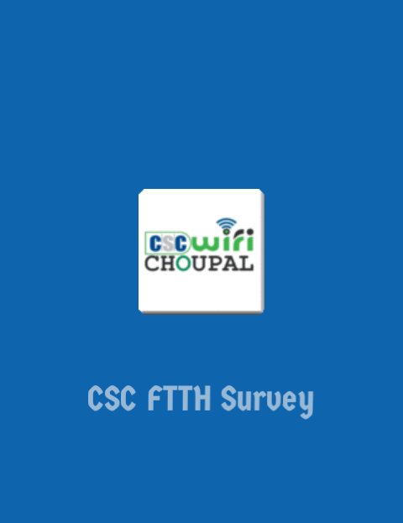

- Login through CSC ID
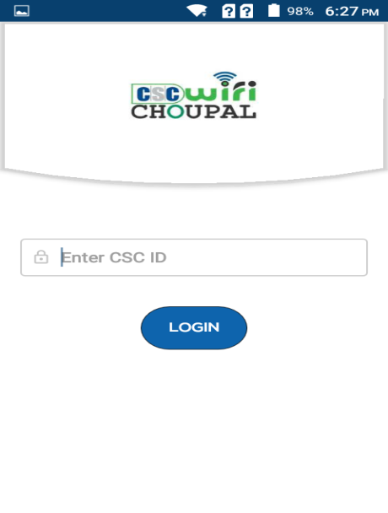

- Screen for creating Password will appear where Password must be created, and after that click on Update Profile option.
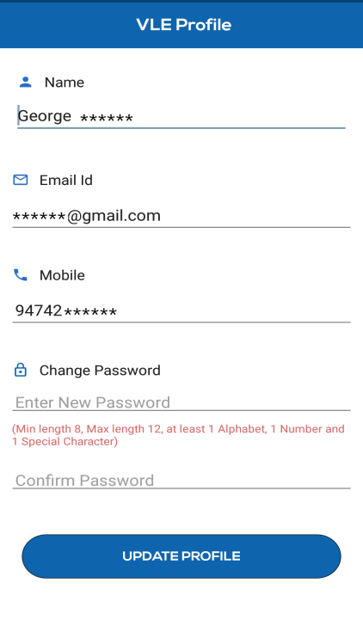

- Then login through CSC ID and newly created password
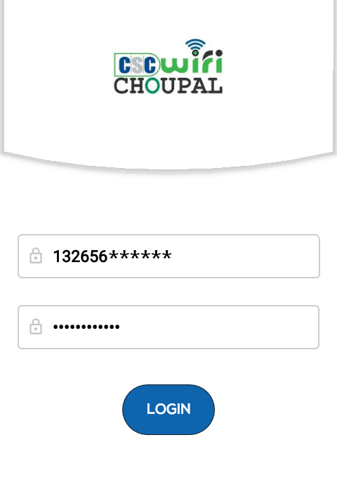

- Home screen for the VLE will appear where VLE will select details (District, Block, GP) and after submission click on Next
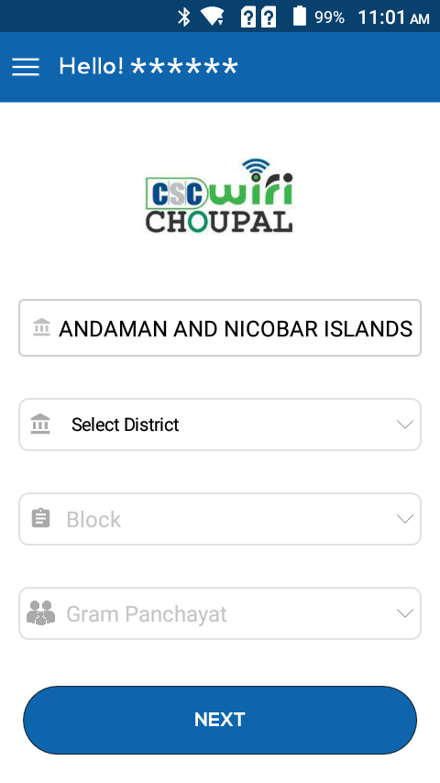

- Fill the form with details regarding GPON location, number of institutions located in a GP (maximum 5 Institutions can be selected). Along with that distance from existing GPON location should be filled.
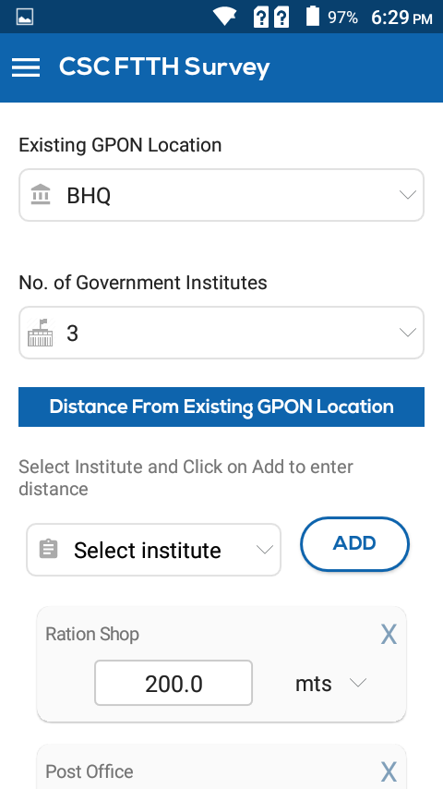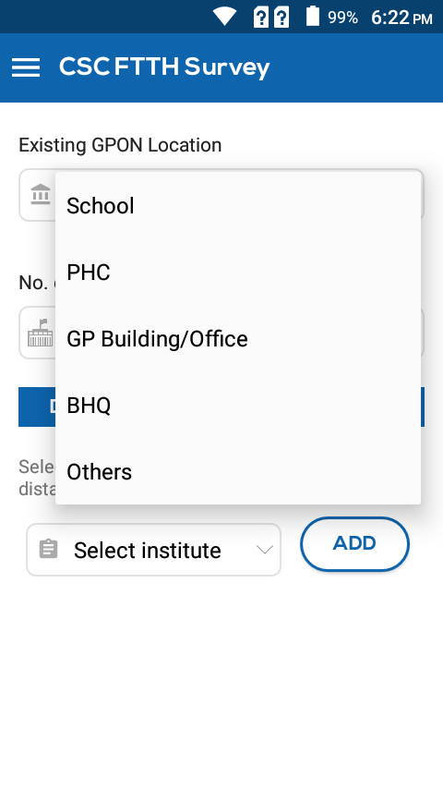
- After clicking on submission, form will be submitted.
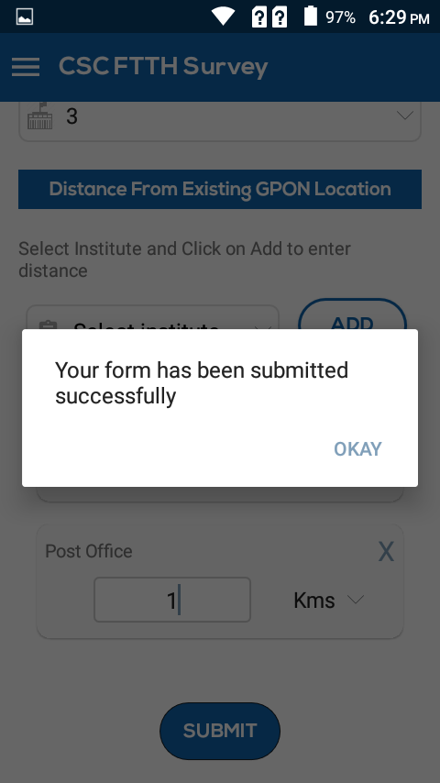

Daily GPON Status
For filling the details related to Daily GPON Status, follow the steps given below:

- On clicking daily GPON Status and home screen will appear for the VLE at which data pertaining to current GPON status must be filled.
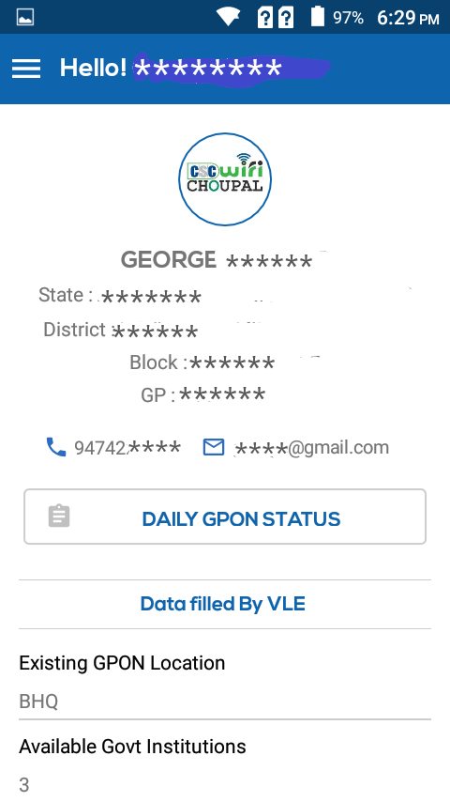
- Fill the ONT mac ID and current status of ONT (UP, Down, Alarm, Missing, Faulty), CCU (UP, Down, Missing, Faulty)
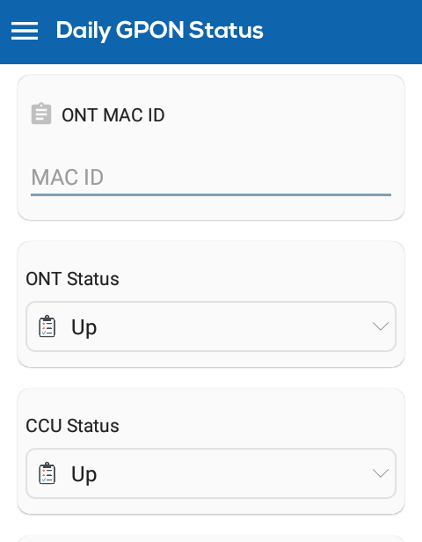

- Also fill the status of Battery (Working, Faulty, Missing, along with Meter Reading data), and Solar Panel (Working, Damage, Missing) and information of FTTH connections, Coupons sold along with amount of coupon sold.
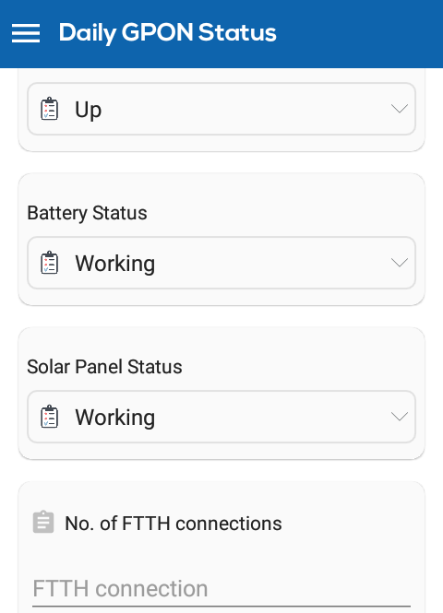

- On the left side panel all the options can be seen by VLE.
